STUDENT CONSENT FORM

2023-2024
AY, Term

I, Joebanezair Buton Buatona, of legal age, hereby expressly state that:

- I have chosen ZHIYUAN ENTERPRISE INC to take my On-the-Job Training (OJT) at, which is of our choosing, for 486 hours in partial fulfillment of the requirements for the degree in BSIT.

- I commit to secure and submit a duly signed and notarized Memorandum of Agreement between ZHIYUAN ENTERPRISE INC and STI College Global City for the conduct of the On-the-Job Training (OJT);

- I have read the rules and regulations set by the STI OJT Course Policy and the Host Training Establishment and commit that I will abide by the said rules and regulations.

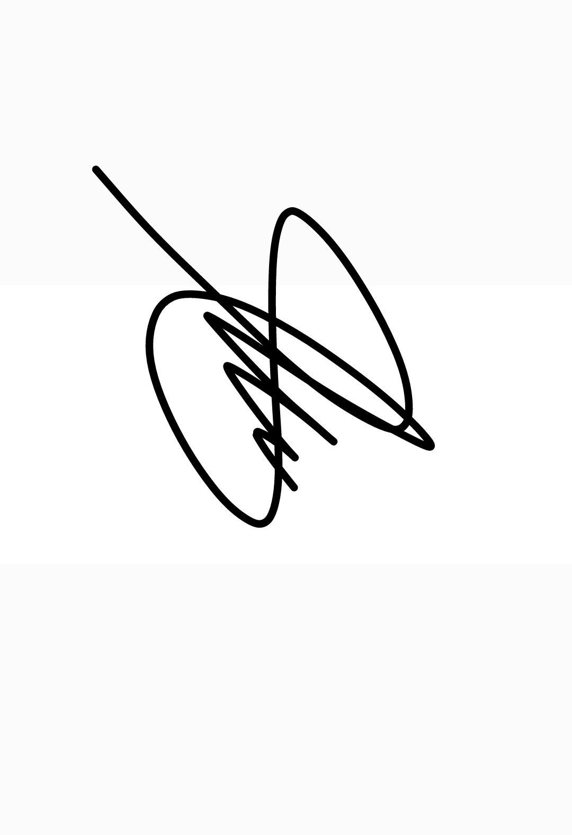
- I fully and voluntarily waive my right to hold STI College Global City and/or any of its officers, employees, or representatives responsible for any case of an untoward incident that may happen to me during the duration of my training.

Joebanezair Buatona 15/02/2024
Signature over Printed Name of Student Trainee Date Signed

Received by:

Joselito Oyao 17/02/2024
Signature over Printed Name of OJT Adviser Date Signed

